Thursday 28th January 2021

T: Can I identify and sort materials into electrical conductors or insulators?

**Today’s activity:**

We know that many electrical conductors are metals such as **copper, iron and steel** and many electrical insulators are made of **plastic, wood, glass and rubber**. Your task today is to complete your table with examples of items that are conductors and insulators. Use the pictures to help you.

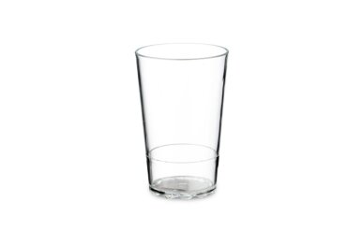

|  |  |
| --- | --- |
| Conductors | Insulators |
|  |  |

